|  |  |  |
| --- | --- | --- |
| **LAB 321Assignment** | **Type:** | **LongAssignment** |
| **Code:** | **J3.L.P0023** |
| **LOC:** | **500** |
| **Slot(s):** | **15** |

**Title:** Electronics Online Store

**Background**

### Now a days , Online store is very common for every salesman .

Complete this assignment to start your business now☺

Reference site:<http://us-123-electronic.simplesite.com/>

**Program Specifications**

Program a web site to make your electronic store online, detail functions of this website is described below

**Features:**

This website contains 3 main functions

* Function 1 : Home page : ( see PIC 01)
  + Display introduction entry and top 6 item sort by publish date
  + Each productcontains
    - Entry name
    - Description picture
    - Entry description
* Function 2 : Online store ( PIC 02)
  + Display all item
  + When user click to “Add to basket” ,”Your basket “ item will increase by 1
  + When user click to “Check out”, display “check out” form
* Function 3 : Contact ( PIC 03)
  + Help user to submit her requests

You do not need to write interface for admin control panel, you can add data manually (use SQL SERVER Management studio).

Note: All data must be load from database, not hard code in page.

***Expectation of User interface:***

Pic 01 : Home Page

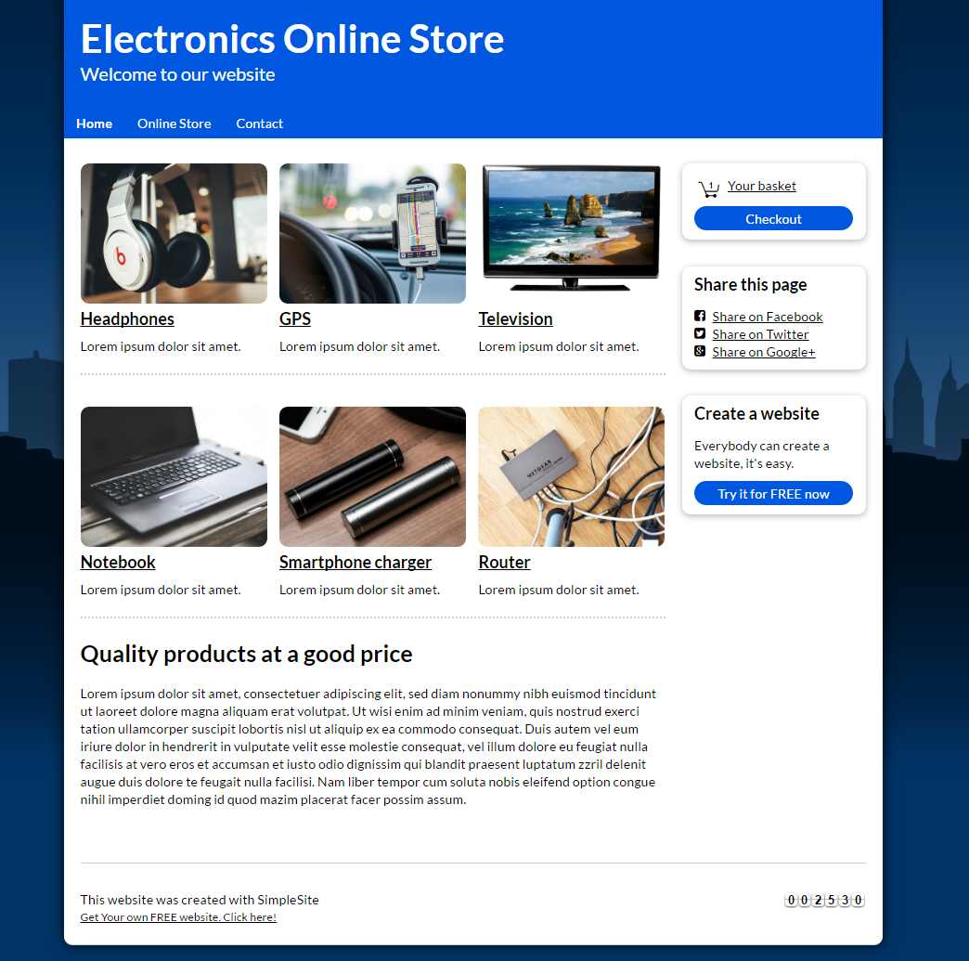

PIC 02 : When user clicks to “check out”, displays checkout form

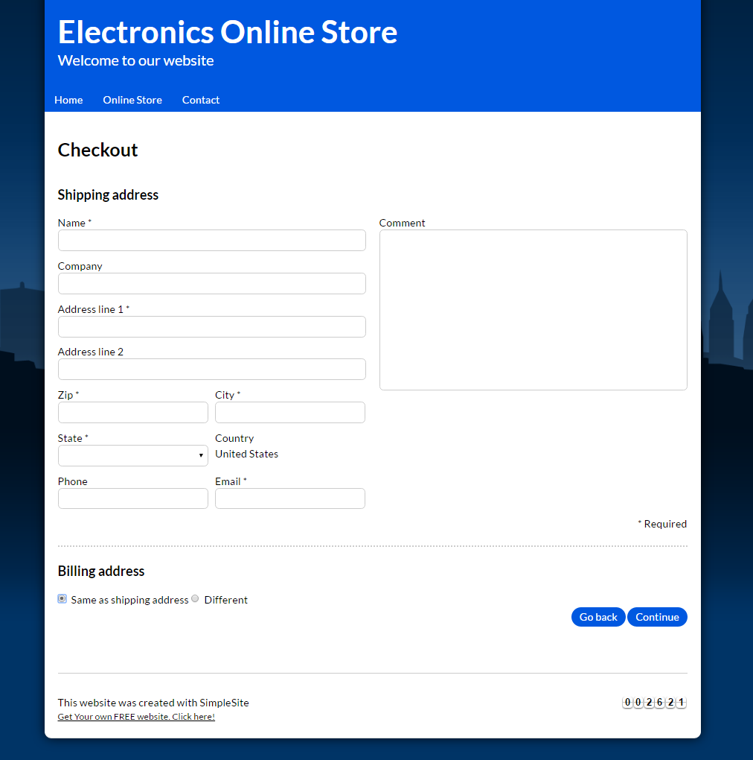

PIC 03 : ONLINE STORE

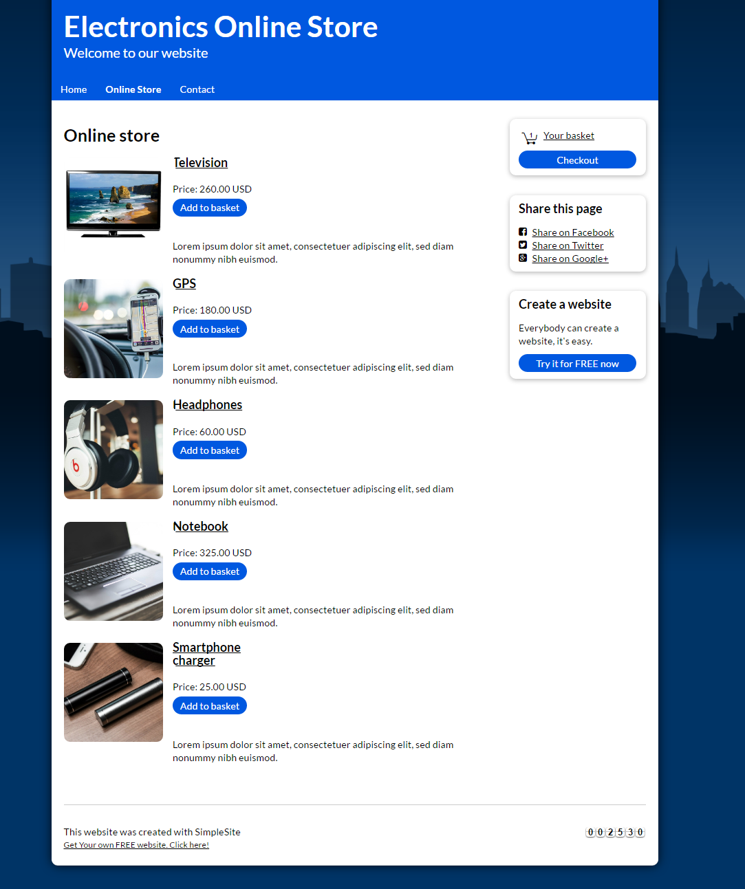

PIC 04 : Display contact information

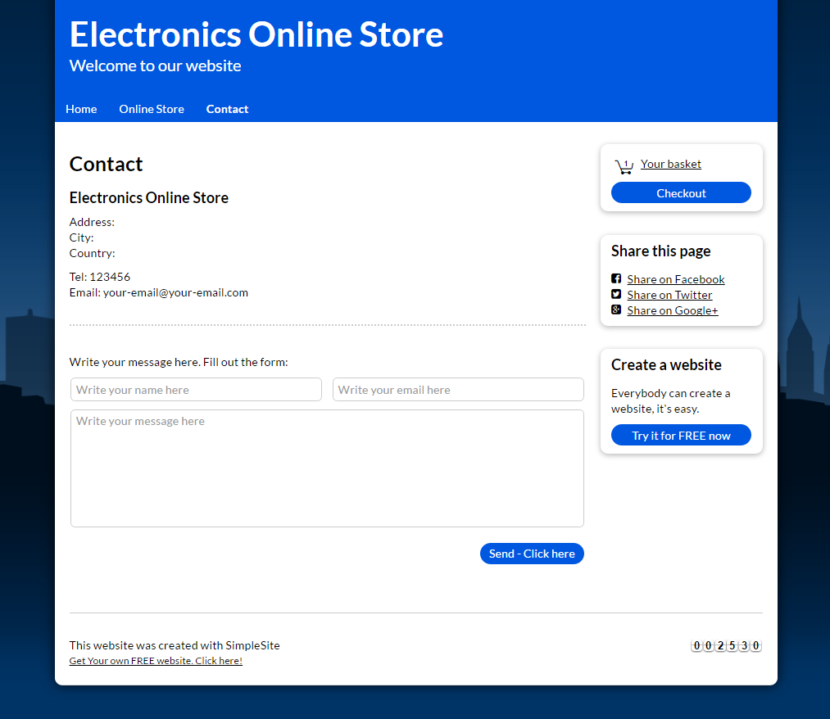

**Guidelines**

* Step 1 : Clarify requirement & scope with mentor
* Step 2 : Create prototype
* Step 3 : Design database base on created prototype
* Step 4 : Code & Test